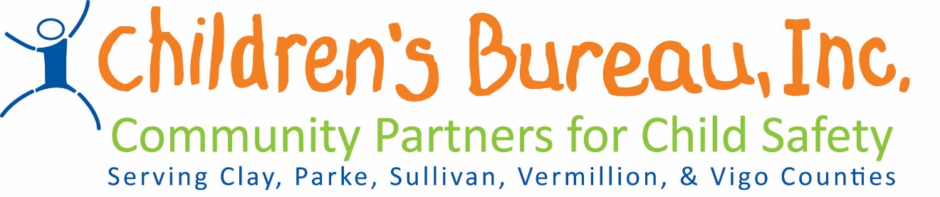
Guidelines for Prevention Grants
- All information is located on the CB webpage at www.childrensbureau.org. Follow the link Instructions for Prevention Grants-Region 08
- All letters of intent should be NO more than 3 pages and are due on March 28, 2018 before 5 pm. All agencies submitting grants will receive an acknowledgement email once the letter of intent is received. All letters of intent must be emailed to ALL of the following:
Jill Kelly, jkelly@childrensbureau.org
Starr Griffin, sgriffin@childrensbureau.org
Susan Lesko, Susan.lesko@dcs.in.gov
- Please keep in mind that all money allocated includes of the 7.5% admin rate
- Please keep in mind that we are asking all agencies to notify both Jill Kelly and Susan Lesko by January 1, 2019 if they are unable to use the money allocated to them in the next cycle.
- Please keep in mind that an additional meeting will be held, as a group, when funds have been allocated. This meeting will include receiving MOU’s, invoices, and a more detailed discussion of billing, fingerprints, etc.

Requirements to be eligible for Brokered Dollars:
- Must provide proof of liability insurance
- Must comply with state requirements regarding criminal checks, cps checks, fingerprinting, and local law enforcement checks
- Must provide services to children and families not involved with the Indiana Department of Child Services or Juvenile Probation

