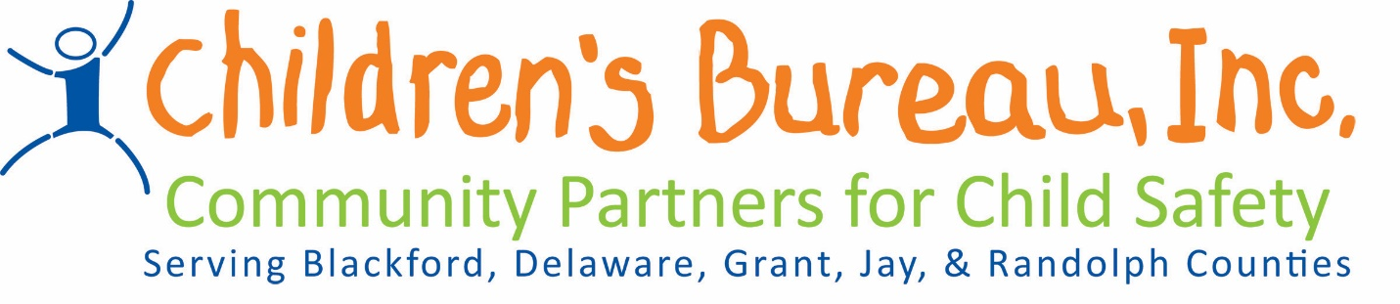

Request for Letters of Intent
Community Based Child Abuse and Prevention Services

The Department of Child Services Regional Service Council for Region 7 along with Children’s Bureau will be selecting Local Child Abuse Prevention Services to be provided within the Region based on the prevention plan. Local Child Abuse Prevention Services are defined as both primary prevention services and secondary prevention services.

Community Partners will fund both primary and secondary prevention programs. Primary prevention is defined as those services and programs that positively influence families, parents, caretakers, and children in the general population before abuse or neglect occurs. Primary prevention services:

- Are accessible to everyone in the community;
- Are received voluntarily;
- Seek to promote positive family functioning rather than preventing problems;
- Attempt to influence social forces which impact parents and children;
- Are culturally responsive to the program participants, building on the cultural strengths of the family and community; and
- Utilize methods which are educational and supportive, rather than clinical or treatment-oriented.

Secondary prevention services are offered to populations considered “at risk” for. Although child abuse or neglect may not have occurred within these families, there is a higher probability that it may occur (or it may have occurred without clear recognition). Secondary prevention services:

- Are offered to a predefined group of vulnerable or “at risk” individuals;
- Are received voluntarily;
- Focus on particular stressors or parenting issues for identified parents and caretakers;
- Seek to promote positive family functioning rather than just preventing problems;
- Build upon participants’ strengths and are not based on a deficit approach; and
- Offer solutions oriented to specific program participants, building on the cultural strengths of the family and community.
The goals or objectives of prevention services are:

- To promote the safety of children
- To reduce the number of children being removed from their parents, guardians, or custodians
- To promote the efficiency of programs and services by coordinating available resources
- To prevent or reduce the number of children who are victims of child abuse, neglect, exploitation, or delinquency

Letters of Intent will be accepted for the following prevention categories:

- Services for victims of domestic violence
- Services providing early education to children and families
- Services aimed at teaching children body safety
- Services aimed at increasing the knowledge of internet and social media safety, knowledge of safe relationships, awareness of potential safety issues with regards to friends
- Services for families affected by substance abuse
- Services that directly prevent children and families from becoming involved in the child welfare system and promote child safety

Proposals should be no more than (3) three pages are due by April 13th, 2018 at 5pm, and should be emailed to:

Denise Lovelace, Director, Dlovelace@childrensbureau.org
Jill Kelly, VP Community Based Services at Jkelly@childrensbureau.org
Kelly Broyles, Regional Manager, at Kelly.Broyles@dcs.in.gov

Decisions will be announced at Regional Service Council on June 8th, 2018.

Guidelines for completing a letter of intent

All letters of intent should include each section below.

Description of the Agency:
This section should include agency background information including a brief description, the agency’s mission, services offered, geographic area served, number of individuals served, and the number of full-time and part-time staff. An organizational chart should also be attached.

Description of Program Services:
Please describe the services being provided with requested funding including any information regarding evidence based services, a description of the target population, how many clients will be served in each county, and how to make referrals to the proposed services.

Definition of how the services help prevent child abuse and neglect:
Please describe the goals of the program and how these goals prevent child abuse and neglect.

Budget and Budget Narrative:
Provide a summary of project budget addressing the type and amount of funds requested, a line item description including staff costs, supplies, space/marketing, or any other costs associated with the project. Please provide a rate per services as well.

Below is a sample Budget:
Staff costs $10,000.00
Curriculum/Materials $ 5,000.00
Presentation per school $ 300.00

Please be aware that payment for brokered dollars is dependent upon funding by the state. Payments are made to you, after funding is received at the Children’s Bureau and it often is paid in approximately 60 days. All agencies being funded through brokered dollars must be an established not for profit agency, must be capable of obtaining appropriate liability insurance before a contract can be completed, and must comply with state regulations regarding background checks, fingerprinting, etc.

Outcomes expected from the program and how they are measured:
Please include expected outcomes and the tracking method for these outcomes.

Please list a Contact person for the program

