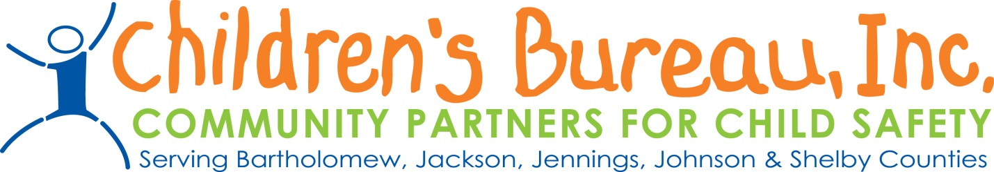
Request For Letters of Intent
Community Based Child Abuse and Prevention Services

The Department of Child Services Regional Service Council for Region 14 along with Children’s Bureau will be selecting Local Child Abuse Prevention Services to be provided within the Region based on the prevention plan. Local Child Abuse Prevention Services are defined as both primary prevention services and secondary prevention services.

Community Partners will fund both primary and secondary prevention programs. Primary prevention is defined as those services and programs that positively influence families, parents, caretakers, and children in the general population before abuse or neglect occurs. Primary prevention services:

- Are accessible to everyone in the community;
- Are received voluntarily;
- Seek to promote positive family functioning rather than preventing problems;
- Attempt to influence social forces which impact parents and children;
- Are culturally responsive to the program participants, building on the cultural strengths of the family and community; and
- Utilize methods which are educational and supportive, rather than clinical or treatment-oriented.

Secondary prevention services are offered to populations considered “at risk” child abuse or neglect may not have occurred within these families, but there is a higher probability that it may occur (or it may have occurred without clear recognition). Secondary prevention services:

- Are offered to a predefined group of vulnerable or “at risk” individuals;
- Are received voluntarily;
- Focus on particular stressors or parenting issues for identified parents and caretakers;
- Seek to promote positive family functioning rather than just preventing problems;
- Build upon participants’ strengths and are not based on a deficit approach; and
- Offer solutions oriented to specific program participants, building on the cultural strengths of the family and community.

The goals or objectives of prevention services are:

- To promote the safety of children
- To reduce the number of children being removed from their parents, guardians, or custodians
- To promote the efficiency of programs and services by coordinating available resources
- To prevent or reduce the number of children who are victims of child abuse, neglect, exploitation, or delinquency

Proposals will be accepted for the following prevention categories:

- Services for families affected by substance abuse
- Services for families affected by domestic violence
- Services aimed at teaching children and teens body safety
- Services aimed at increase knowledge of internet safety, knowledge of safe relationships, awareness of potential safety issues with regards to friends, internet, parents, and self, and increases community awareness of abuse and neglect
- Services that directly prevent children and families from becoming involved with the Department of Child Services and keep children safe

Proposals are due by Wednesday April 6th, by 5pm and should be emailed to:

Jill Kelly, VP of Community Based Programs at Jkelly@childrensbureau.org
Rachelle Steele, Director, Rsteele@childrensbureau.org
Traci Eggleston, Regional Manager at Traci.eggleston@dcs.in.gov

Decisions will be announced at RSC on May 15th, at 8:30am.

Guidelines for Completing a Letter of Intent

All proposals should include each section below.

Description of the Agency:
This section should include the following:
Agency background information including a briefly description your agency, including its mission, services offered, geographic area served, number of individuals served, and number of full-time, part-time staff. An organizational chart should also be attached.

Description of Program Services:
Please describe the services being provided with requested funding, including background information about the history, any information regarding evidence based services, the target population, how many clients will be served in what county, and how to make referrals to the services. Please include geographic boundaries of the program.

Definition of how the services help prevent child abuse and neglect:
Please describe the goals of the program and how these goals prevent child abuse and neglect.

Budget and Budget Narrative:
Provide a summary of project budget addressing the type and amount of funds requested, a line item description including staff costs, supplies, space/marketing, or any other costs associated with the project.

Below is a sample Budget:
Staff costs $10,000.00
Curriculum/Materials $ 5,000.00
Presentation per school $ 300.00

Please be aware that payment for brokered dollars is dependent upon funding by the state. Payments are made after funding is received at the Children’s Bureau and is often paid in approximately 60 days. All agencies being funded through brokered dollars must be an established not-for-profit agency, must be capable of obtaining appropriate liability insurance before a contract can be completed, and must comply with state regulations regarding background checks, fingerprinting, etc.

Outcomes expected from the program and how they are measured:
Please include expected outcomes and the tracking method for these outcomes.

Please list a contact person for the program, including email address.
Proposals should be no longer than 3 pages.

