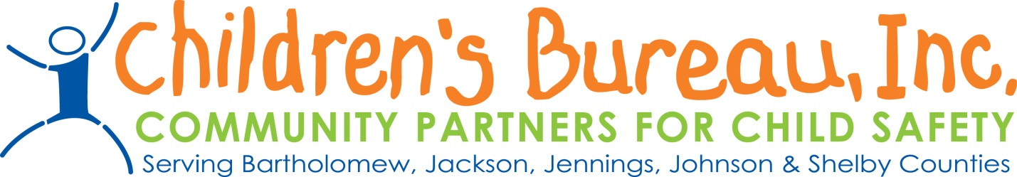
Announcement: Bidders Conference for
Prevention Dollars

Children’s Bureau will be hosting a Bidders Conference for Prevention Dollars in Region 14 on Thursday, March 12th from 10:00am to 11:00am at the United Way Building, Board Room. The address of the location is 1531 13th St, Columbus, IN 47201. Please attend the Bidders Conference to receive information and guidelines on how to complete a letter of intent; what is needed to apply; and to receive information on background checks, payment process, and invoices. If you plan to apply for funding, attendance at the Bidders Conference would be advisable.

We will be accepting Letters of Intent for Region 14 providers that wish to apply for funding to provide services that address the prevention of child abuse and neglect. Letters of Intent will be accepted from March 12th, 2020 until April 17th, 2020 at 5pm. These Letters of Intent are for those agencies or individuals applying for prevention grants in Region 14 for the 2020-2021 grant year beginning 7-1-2020. All Letters of Intent should be submitted electronically to the following:

Jill Kelly, VP of Community Based Services, jkelly@childrensbureau.org
Claire Winship, Director, Community Partners cwinship@childrensbureau.org
Traci Eggleston, Regional Manager, DCS, Traci.eggleston@dcs.in.gov

All Letters of Intent are due by 5pm on Friday, April 17th, 2020, and the decision will be announced at RSC on May 19th, 2020. Please email Jill Kelly with any questions.

Please go to the Children’s Bureau website for more information. www.childrensbureau.org. Follow the link to instructions for Region 14 Prevention Funding.

