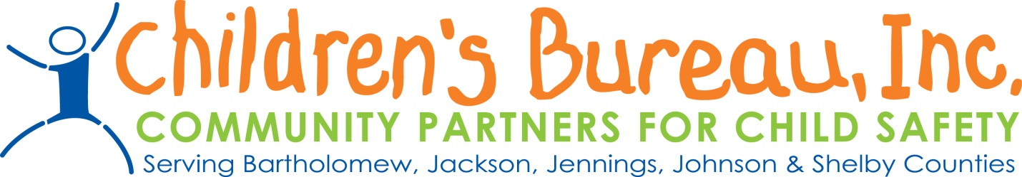
Guidelines for Prevention Grants
- All information is located on the CB webpage at www.childrensbureau.org. Follow the link Instructions for Prevention Grants-Region 14
- All letters of intent should be NO more than 3 pages and are due on April 17th, 2020 by 5 pm. All agencies submitting grants will receive an acknowledgement email once the letter of intent is received. All letters of intent must be emailed to ALL of the following:
Jill Kelly, jkelly@childrensbureau.org
Claire Winship, cwinship@childrensbureau.org
Traci Eggleston, traci.eggleston@dcs.in.gov

- Please keep in mind that all money allocated includes of the 7.5% admin rate
- Please keep in mind that an additional electronic communication will be held when funds have been allocated. This communication will include receiving MOU’s, invoices, and a more detailed discussion of billing, fingerprints, etc.

Requirements to be eligible for Brokered Dollars:
- Must provide proof of liability insurance
- Must comply with state requirements regarding criminal checks, cps checks, fingerprinting, and local law enforcement checks
- Must provide services to children and families not involved with the Indiana Department of Child Services or Juvenile Probation

